

PIPELINE ROW PATROL INSPECTION REPORT

Howard Energy / GT Logistics

# Sabine Bayou Port Arthur Area

June 19, 2025

# CONFIDENTIAL DOCUMENTS

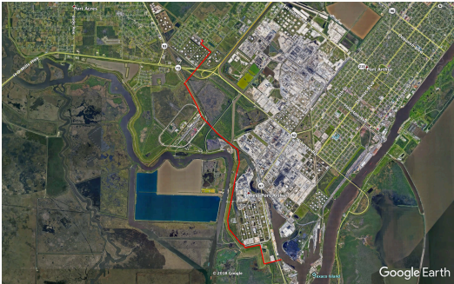

Arch Aerial, LLC 3701 Yale Street

Houston, TX 77018

281.974.5752